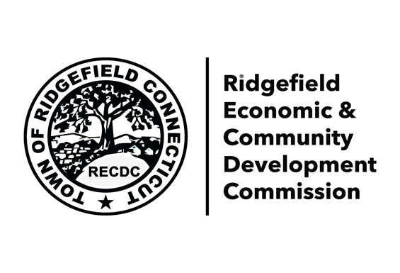
400 Main Street • Ridgefield, CT 06877•203.546.2547

Glori Norwitt - Chair Rudy Marconi, First Selectman
Geoffrey Morris – Secretary ridgefieldct.com
Sean Dowd
Kay Gelfman
Jennifer Gioffre
Brittny Howell
Bob Knight
Mark Riser
Jonathan Winn

Meeting Agenda
August 7, 2023 at 6:30pm
In-person in Town Hall Large Conference Room

Policy: Economic & Community Development Commission (ECDC) meetings will be conducted under Robert’s Rules of Order with comment invited only on agenda items that are action items not subject to formal public hearing. Individuals will be recognized for three minutes after ECDC discussion and before ECDC vote. All participants are expected to conduct themselves with dignity and treat all those present with respect, empathy and civility. Debates are to remain respectful and civility must prevail. Public comment is available.

Announcements
Next meeting: September 11, 2023
Approval of July 2023 Minutes

General Discussion
Public Comment
Recap of Recent Events/Info
Tiger Shark Tank (Dowd, Riser)
Cultural District Sculpture (Morris, Gelfman)
Cultural District (Norwitt, Morris)
Business Connections (Gioffre)
Business Programs (Riser)
Marketing (Howell, Gioffre, Morris)
Updates from Planning & Zoning (Gelfman)
Management Assessment by CT Main Street Center (Norwitt, Morris)
ECDC Annual Report
Strategic Planning

Public Comments can be submitted prior to or after the meeting to: ecdc.norwitt@gmail.com

